**Mongodb Lab Assignment 2**

MongoDB -Aggregation Exercises Import the zips.json file into your MongoDB. Database name is "population" and collection name is "zipcodes". mongoimport --db population --collection zipcodes --file zips.json

Atlanta Population

1. use db.zipcodes.find() to filter results to only the results where city is ATLANTA and state is GA.

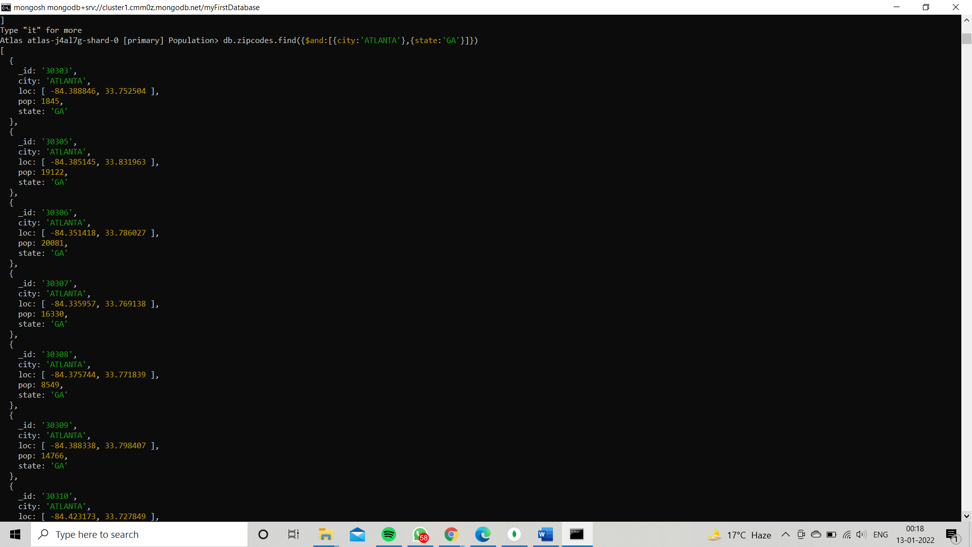

1. use db.zipcodes.aggregate with $match to do the same as above.

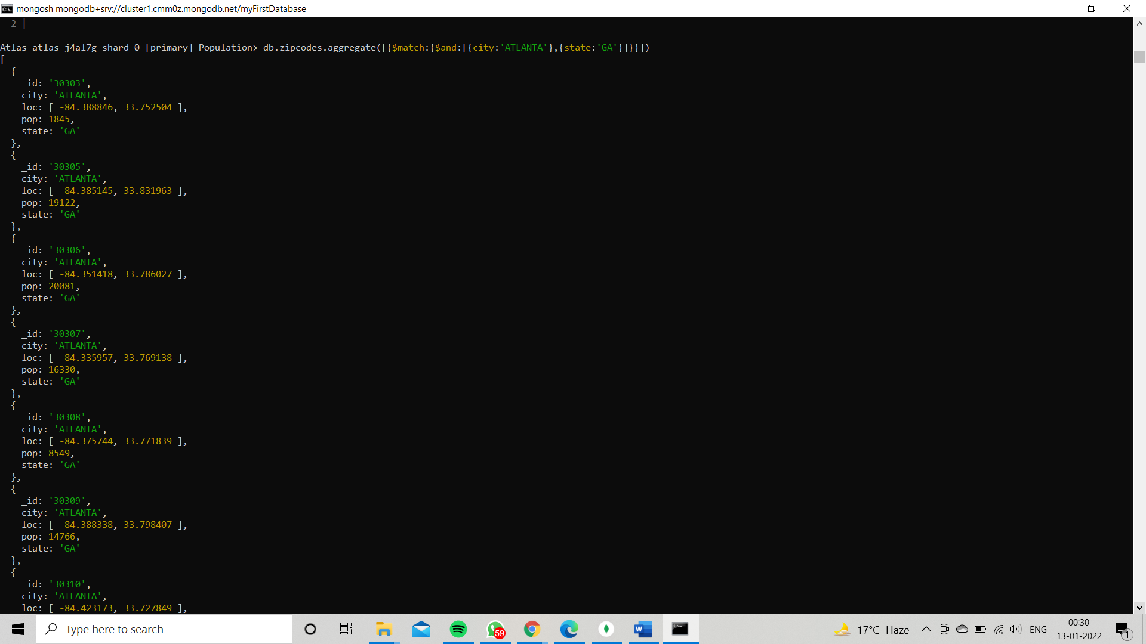

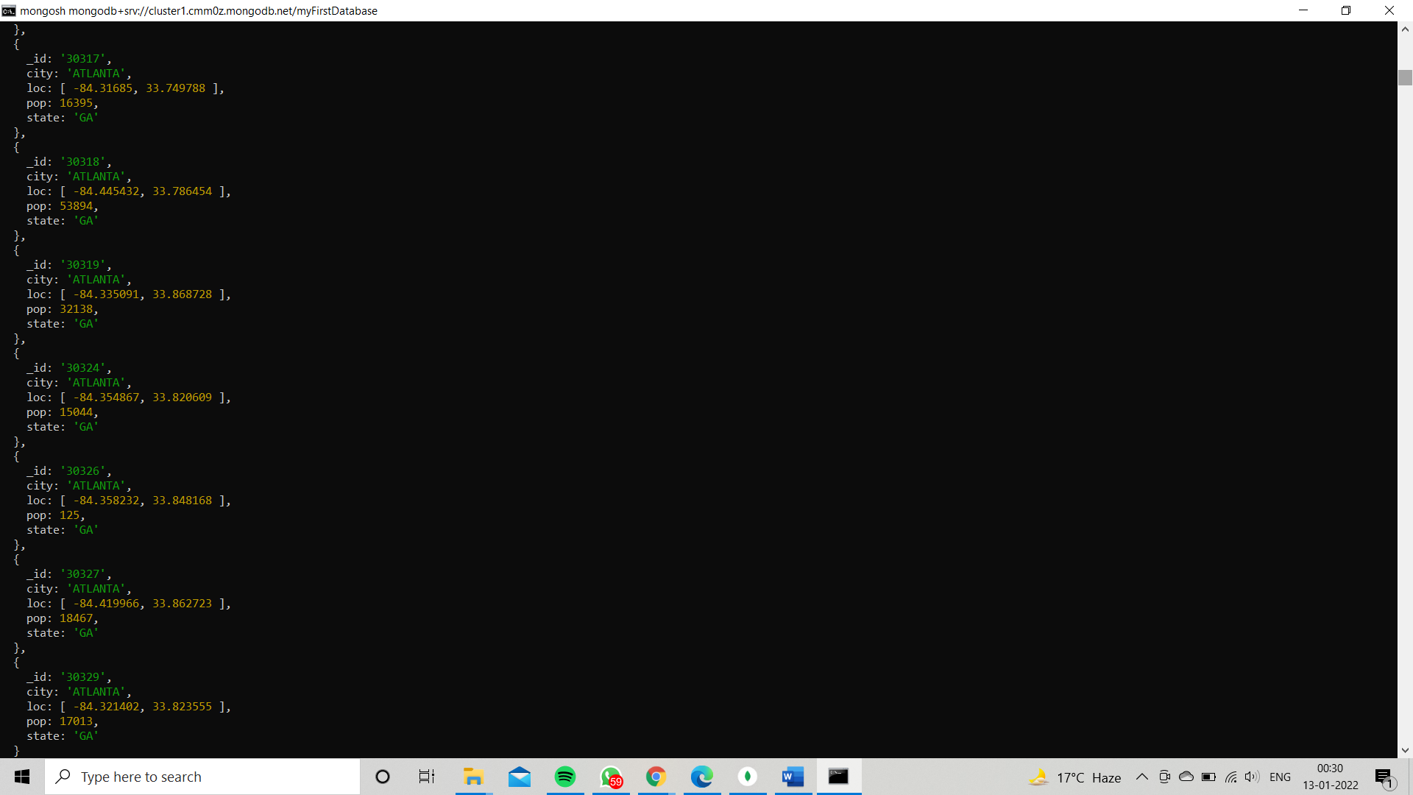

1. use $group to count the number of zip codes in Atlanta.

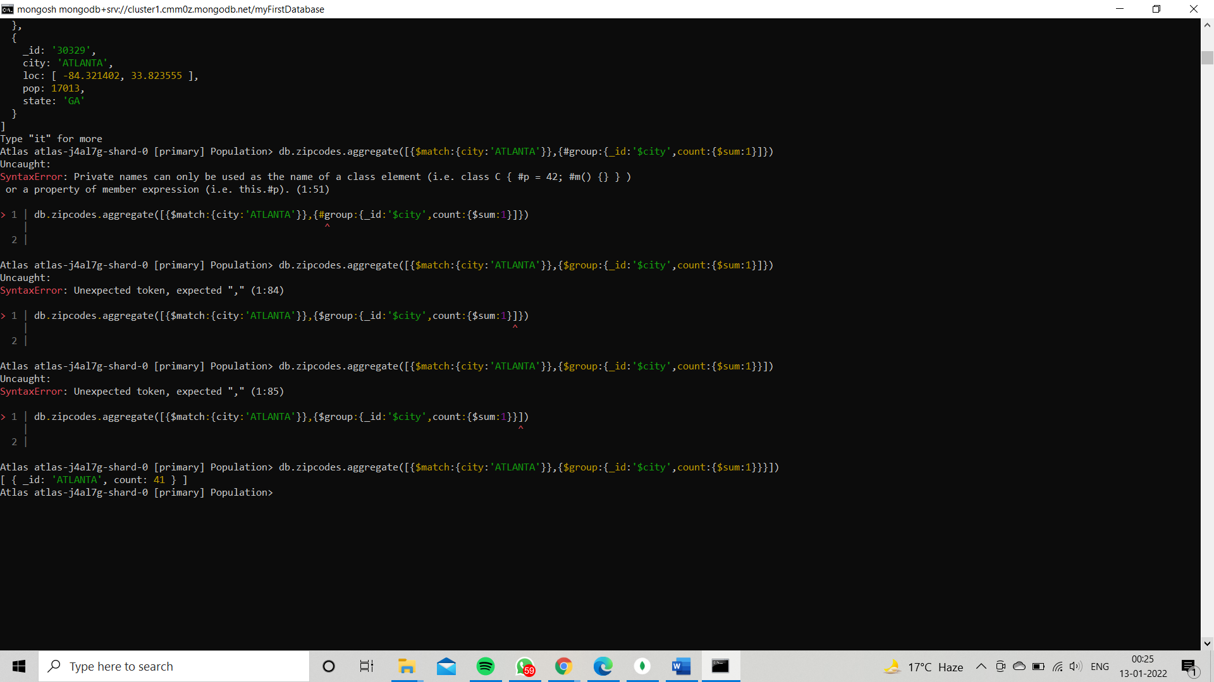

1. use $group to find the total population in Atlanta.

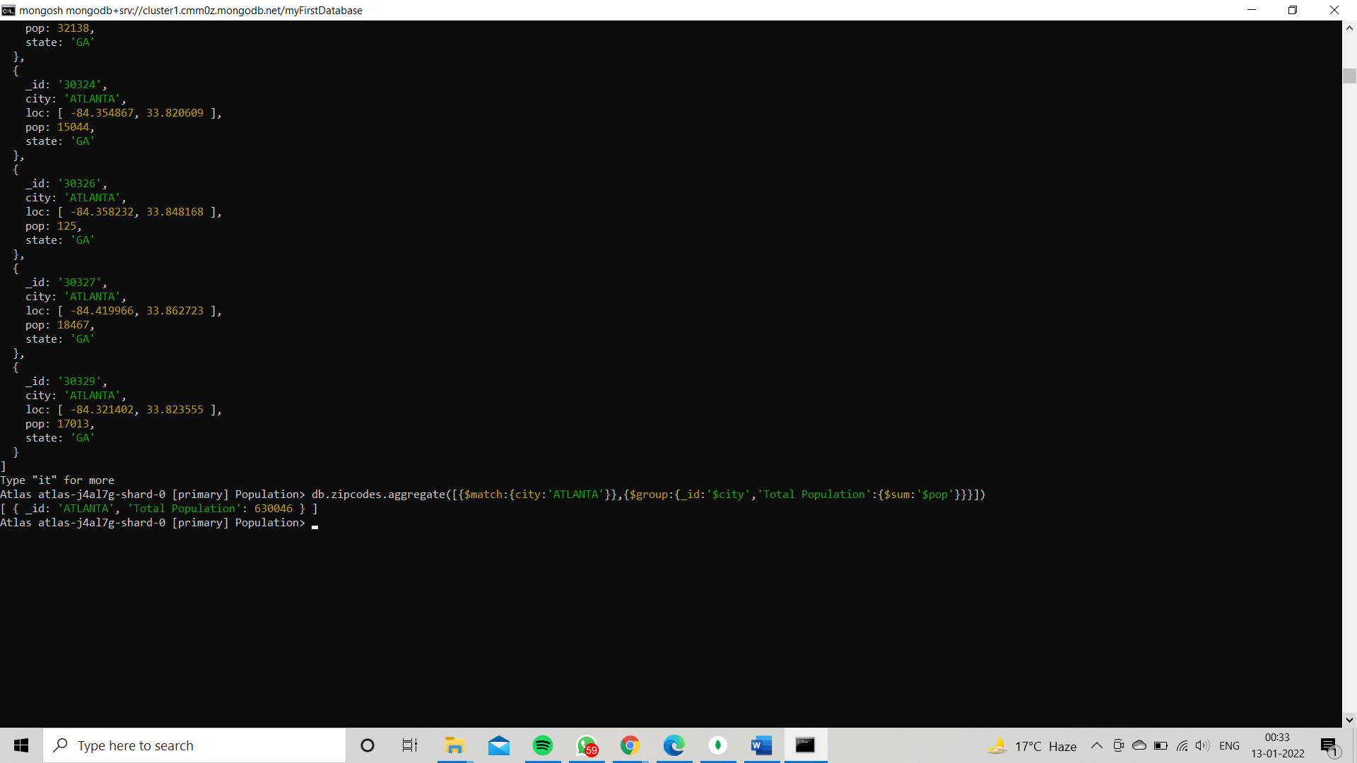

**Populations By State**

1. use aggregate to calculate the total population for each state

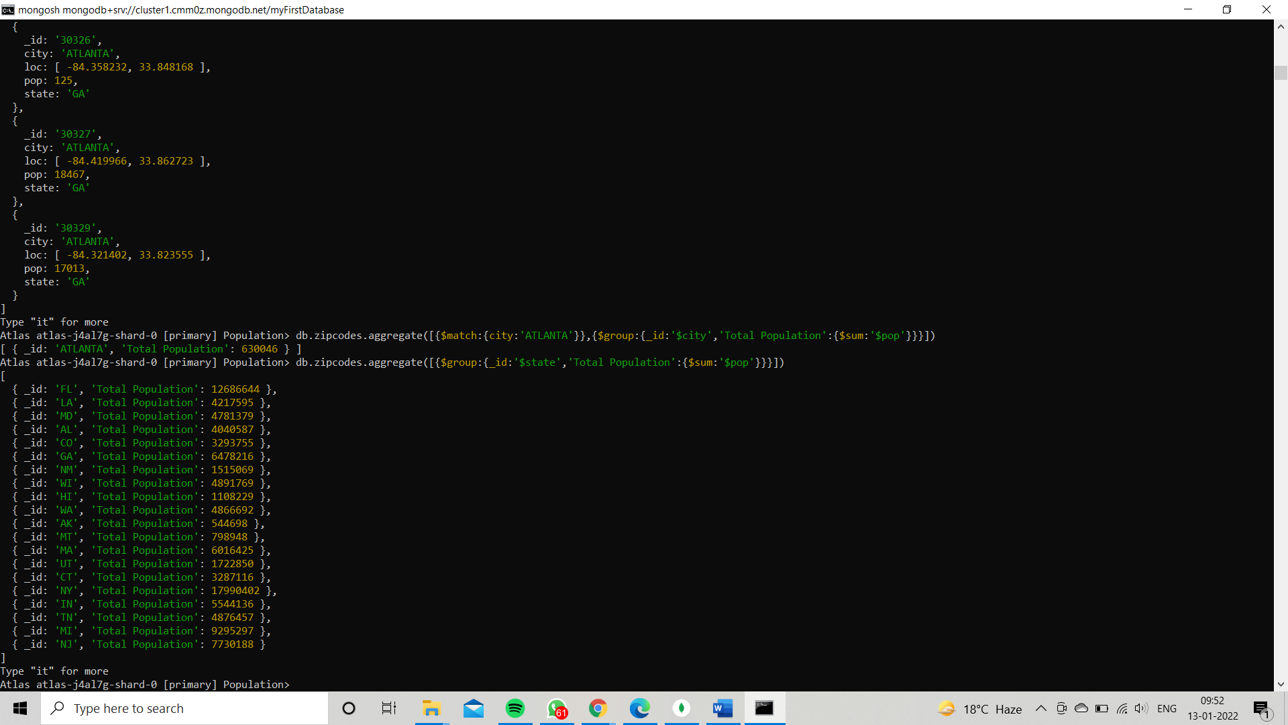

1. sort the results by population, highest first 3. limit the results to just the first

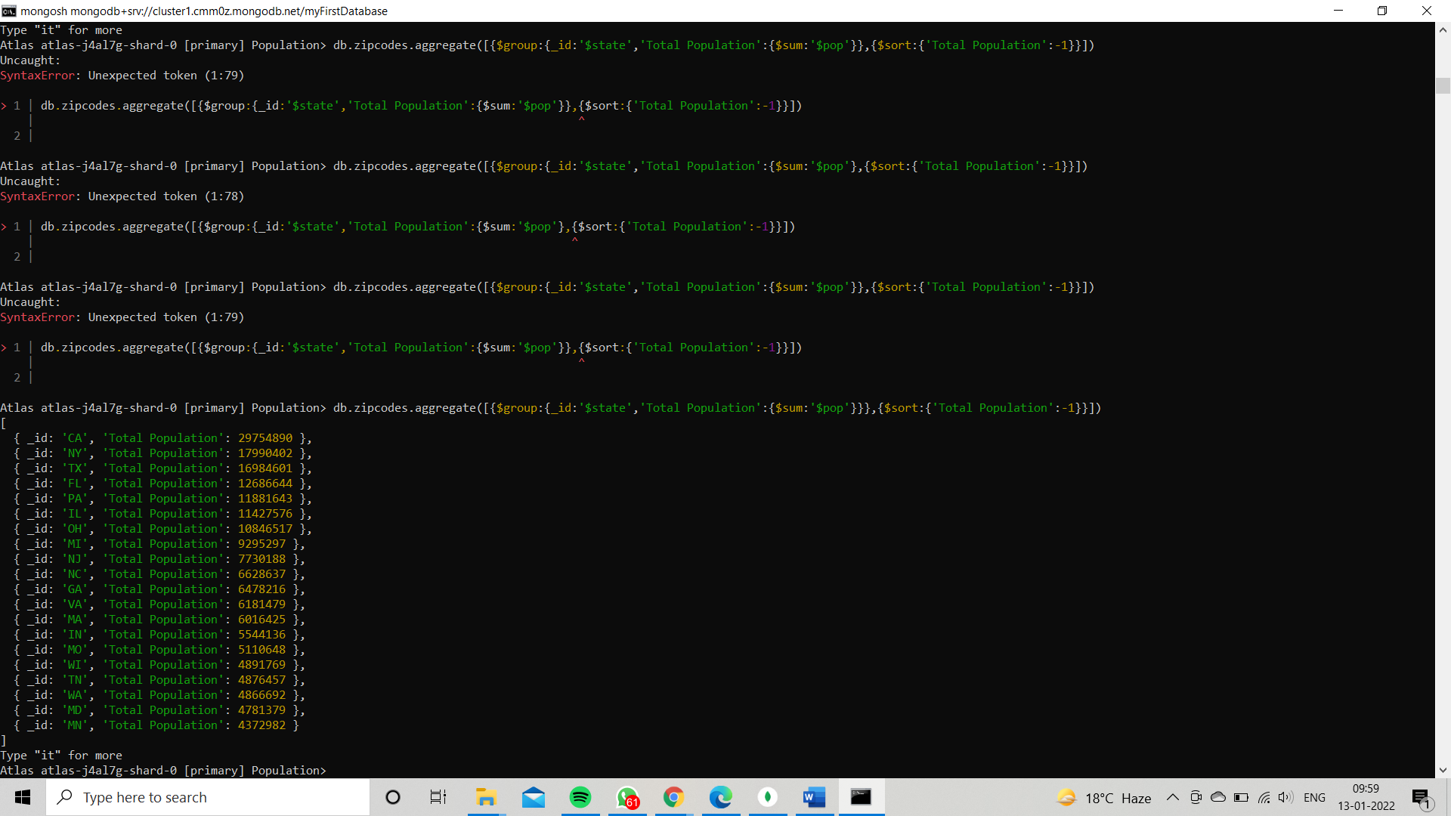

3 results. What are the top 3 states in population?

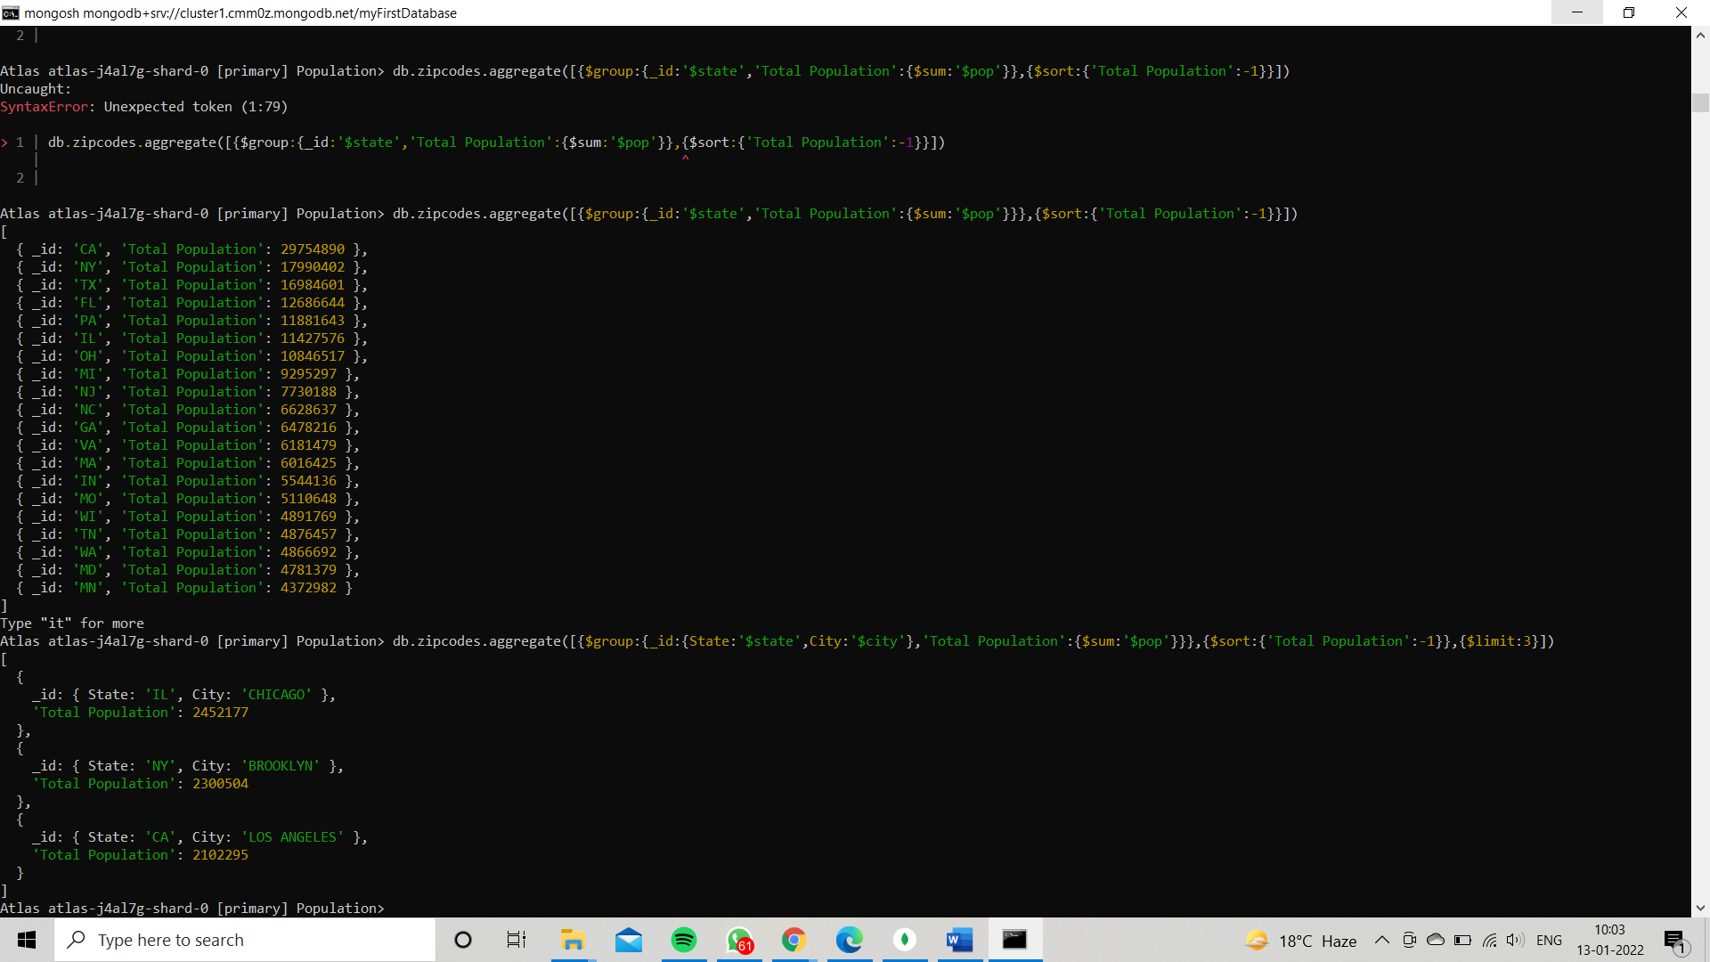

**Population by City:**

1.use aggregate to calculate the total population for each city (you have to use city/state combination). You can use a combination for the _id of the $group: { city: '$city', state: '$state' }

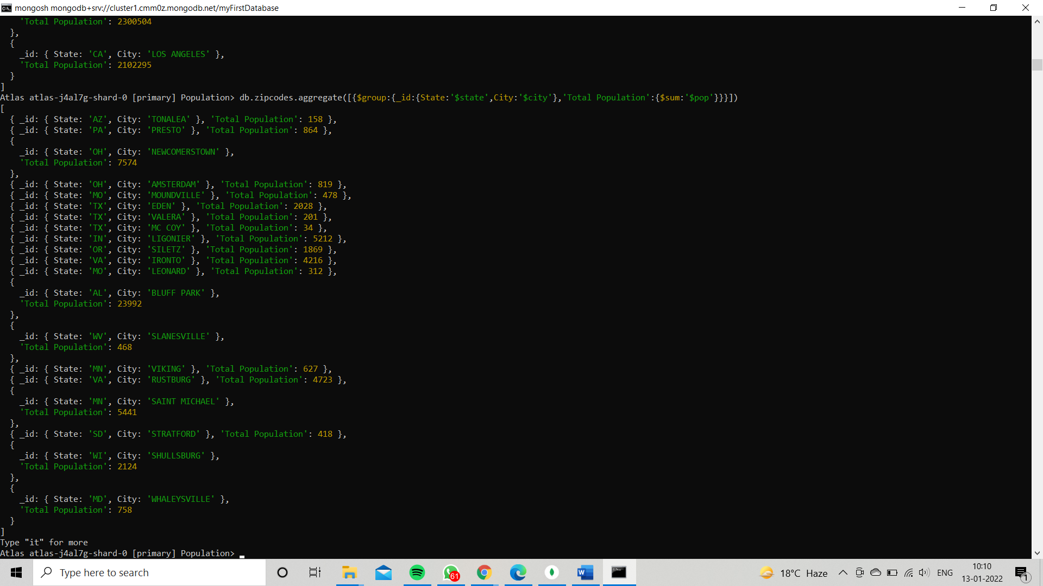

2.sort the results by population, highest first

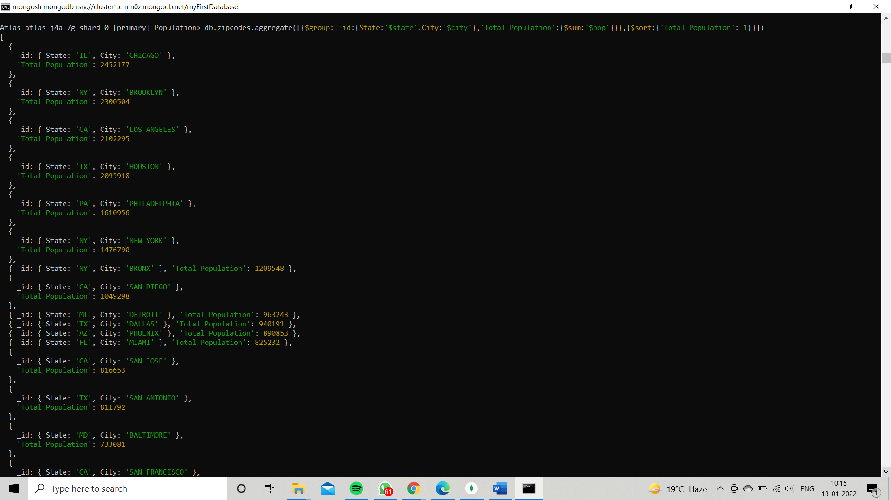

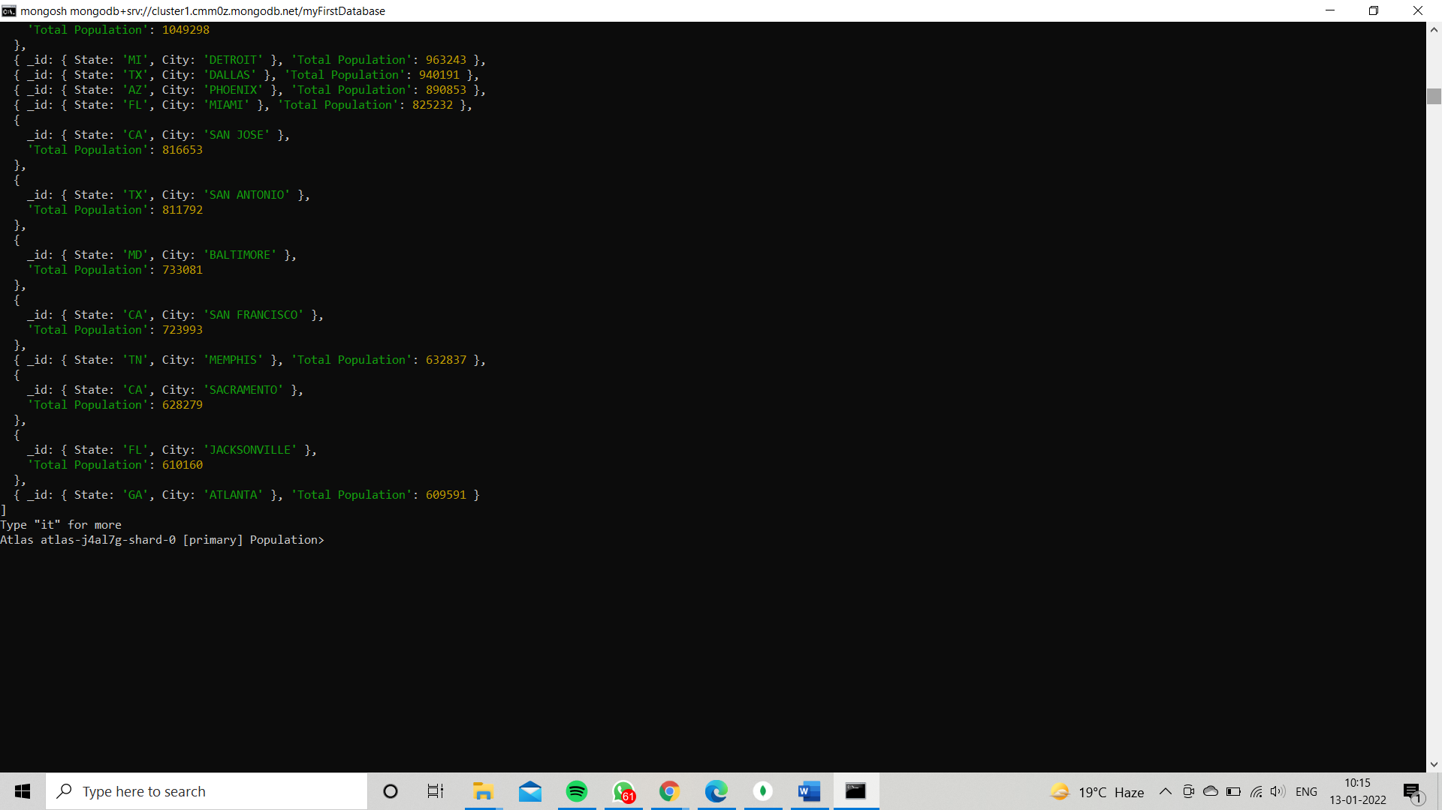

3.limit the results to just the first

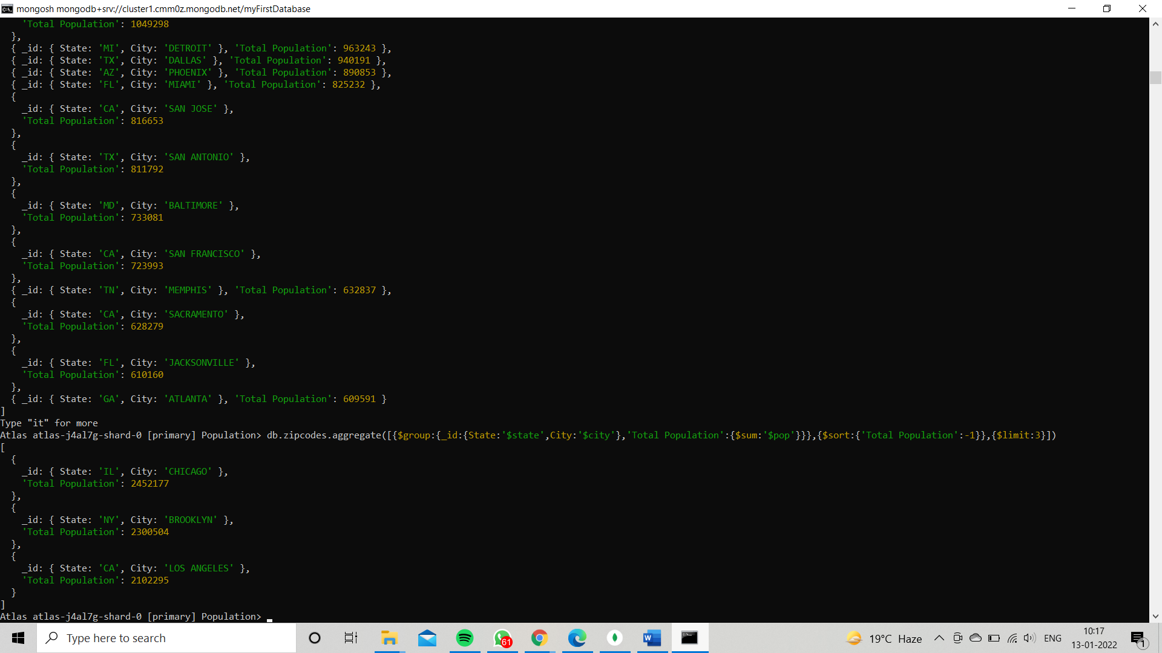

3 results. What are the top 3 cities in population? 4. What are the top 3 cities in population in Texas?

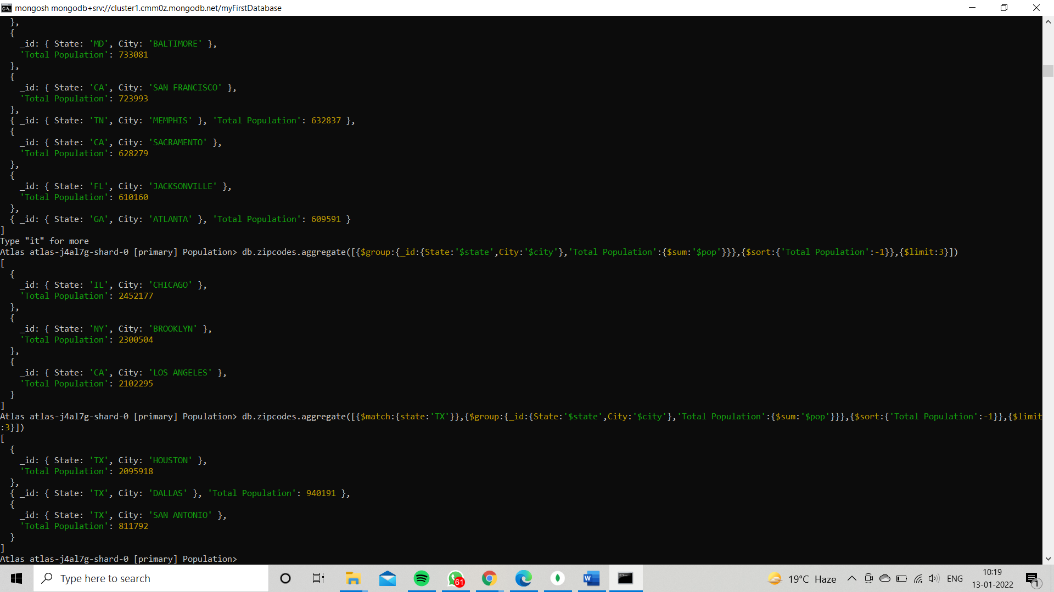

**Bonus:**

1.Write a query to get the average city population for each state.

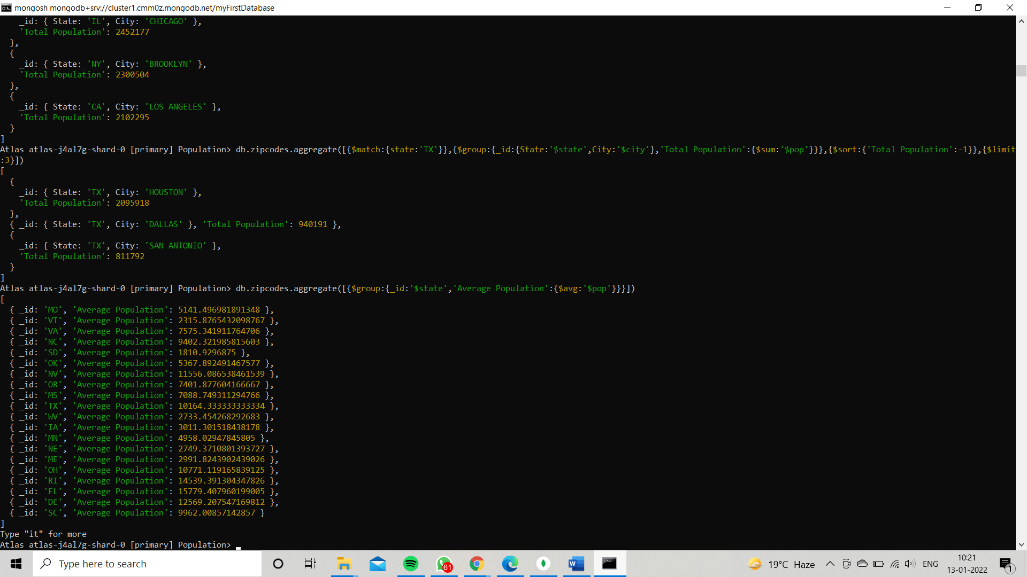

2.What are the top 3 states in terms of average city population

